OpenStack Rocks in Poland

Join the 1st OpenStack User Group Meetup in Szczecin (Poland) 06-06-2013, Technopark Pomerania, Niemierzynska 17a (3rd Floor, room 301), Szczecin, Poland: with Boris Renski (Mirantis), Tim Bell (CERN), Eric Windisch (Cloudscaling) & Atul Jha (OpenStack India)

We are excited to announce our first OpenStack Meetup in Szczecin (Poland) on June 6th 2013, 5.00 pm CEST (GMT + 2 hrs) at Hackerspace in Technopark Pomerania, an IT hub for local public and private tech ventures. Our meetup will be accompanied by Google Hangout and IRC Chat sessions with some of the most respected members of the OpenStack community: Boris Renski of Mirantis, Tim Bell of CERN, Eric Windisch of Cloudscaling and Atul Jha of the OpenStack User Group India.

OpenStack aims to become the open standard for an ubiquitous cloud

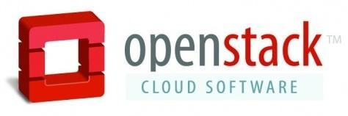
OpenStack was launched jointly by Rackspace and NASA in 2010. It is managed by the OpenStack Foundation. OpenStack is written in Python and licensed under Apache License 2.0.

OpenStack is an open source software for building private and public clouds. It’s supported by a vast community of more than 200 vendors such as Cisco, Dell, HP, IBM, Redhat and VMware. More than 800 developers are contributing to the code base and 6,000 individual members are backing the initiative.

“OpenStack aims to be an alternative to proprietary private and public cloud solutions. But the ultimate goal is even bolder, as leading OpenStackers claim: to create an ubiquitous, free and open cloud standard - just as the internet as we know it today.” explains Rafael Knuth, who is co-organizing the OpenStack User Group Meetup jointly with Rafal Malujda and Michal Smereczynski under the patronship of Aegis Foundation, a Poland based Free and Open Source Software (FOSS) Foundation: “The current state of affairs with cloud is being compared to the internet in the 1990s: a collection of gated communities operated by vendors like CompuServe and Prodigy. Tearing down these walls might reshape the entire IT industry and create opportunities for businesses and organizations far beyond anyone’s imagination.” - explains Knuth.

Our meeting shall be the first meeting in the series to support the local community, especially gathered in the regional Cluster of IT companies (ICT Westpomerania Cluster) in understanding OpenStack soultions.

“ICT Cluster is an association of nearly 60 ICT companies in the West Pomerania Region. We cooperate to improve the potential of regional IT companies. And Pomerania Technopark is a place, where we can meet to exchange knowledge and experiences. We hope that the 1st OpenStack User Group Meetup will begin an effective cooperation between members of the OpenStack community” – says Katarzyna Witkowska, ICT Cluster vice president.
Join our Google Hangout and IRC Chat at 5 pm CEST (GMT + 2 hrs)

Don’t miss the opportunity to chat online with our special guests. We will open our Google Hangout and IRC Chat session on June 6th at 5.00 pm CEST (GMT +2 hrs), and both will remain open until approximately 9 pm CEST (GMT + 2 hrs).

OpenStack Poland - IRC Channel
#openstack-pl
server: freenode
for non-IRC users: http://openstackpoland.aegis.org.pl/irc-channel/

Google Hangout

https://www.youtube.com/user/OpenStackPoland

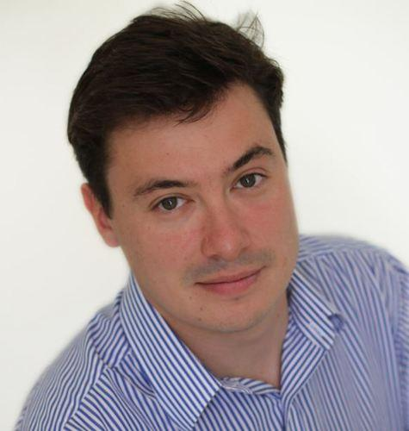
Follow Boris at Twitter: @zer0tweets

Boris Renski is member of the OpenStack Board of Directors. He is co-founder and EVP at Mirantis, the world’s largest independent OpenStack system integrator. Mirantis is serving customers such as at&t, NASA, Huawei, Dell, Cisco, HP and GAP. Earlier this year, Mirantis released FUEL, an open-source library packaging the company’s implementation experience into an OpenStack Do-it-Yourself-Kit. Mirantis is headquartered in Mountain View and operates across five additional international locations in Russia, Ukraine and Poland.

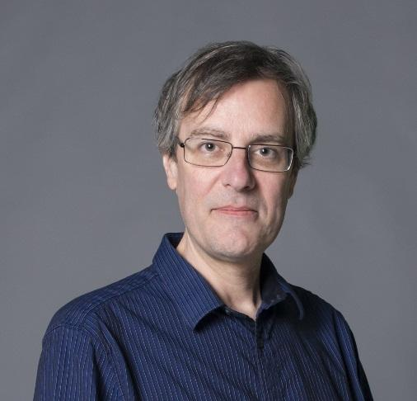
Follow Tim at Twitter: @noggin143

Tim Bell is member of the OpenStack Board of Directors. Tim works as Infrastructure Manager at CERN, the European Organization for Nuclear Research. CERN is an active member of the OpenStack community and openly shares their best practices. Their goal for OpenStack is to ramp to 15,000 hypervisors with 100,000 virtual machines by 2015.

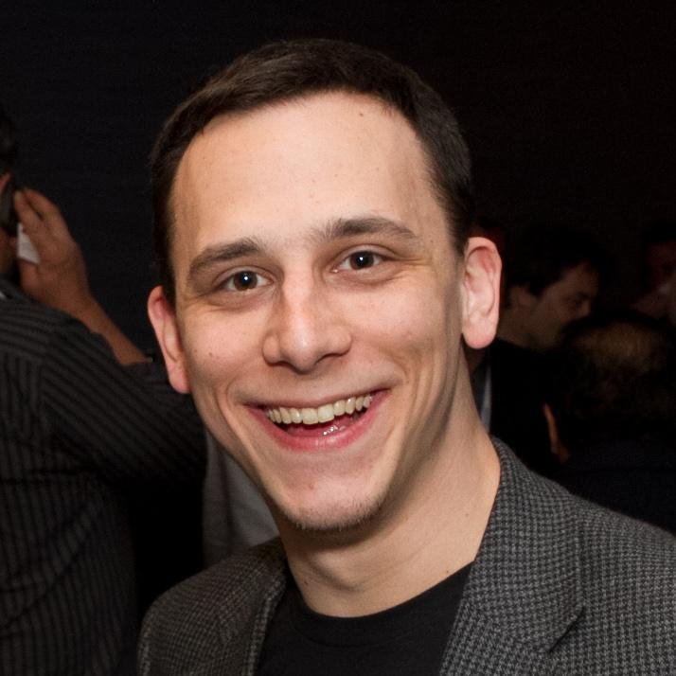
Follow Eric at Twitter: @ewindisch

Eric Windisch works as a Cloud Architect at Cloudscaling, the company behind the OpenStack distribution Open Cloud System 2.5 designed to meet the requirements of today’s web/mobile applications, SaaS/PaaS deployments and big data implementations. Eric is also contributing to Cloudscaling’s engineering blog Simplicity Scales.

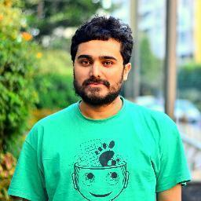
Follow Atul at Twitter: @koolhead17

Atul Jha is an active member of the OpenStack community in India. He is engaging with a broad range of enterprises as well as with the higher education sector, the latter seizing opportunities in the OpenStack ecosystem for their students: “Open Source Software Isn’t Just Code. It’s Your Résumé” as recently stated in WIRED.com.

Targeting Central & Eastern Europe

We aim to serve the local IT community as well as the OpenStack ecosystem across the entire CEE region. For that reason we join forces with the OpenStack User Group in Hungary which is organizing the OpenStack CEE Day in Budapest May 29th 2013. Also, we will engage and share experiences with other emerging regions such as India, China and Brazil.

Register for the event at Meetup.com

Please register for the event at Meetup.com. Also, don’t hesitate to get in touch with us. We will happily answer your questions and discuss with you via the global OpenStack Community mailing list, our local OpenStack mailing list (URLs below) as well as via Twitter: Rafael Knuth (@RafaelKnuth) Rafal Malujda (@Raafael6000) Michal Smereczynski (@Smereczynski) - don’t forget to use the #OpenStack hashtag.

OpenStack Poland resources

Webpage:
http://openstackpoland.aegis.org.pl/
Meetup page:
http://www.meetup.com/OpenStack-User-Group-Poland/
Global community mailing list:
http://lists.openstack.org/cgi-bin/mailman/listinfo/community
Local community mailing list (in Polish):
http://lists.aegis.org.pl/mailman/listinfo/openstackpoland

